NETFLIX CONTENT ANALYSIS
POWER BI PROJECT
DETAILED PROJECT DOCUMENTATION

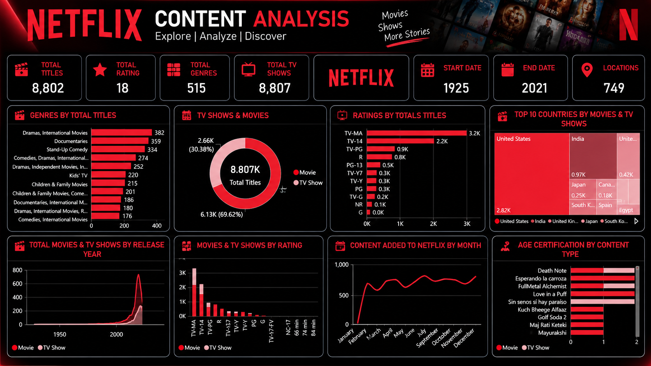

Submitted By: Gunda Swapthika
Trainer Name: Mangali Rakesh
Tool Used: Microsoft Power BI
Dataset: Netflix Titles Dataset

1. INTRODUCTION
Netflix is one of the most popular digital streaming platforms in the entertainment industry. It provides a large collection of movies, television shows, documentaries, and other digital content. Users can access content from different countries and in different languages. Because the platform contains a large number of titles, analyzing its content library can help us understand the type of content available and the way the library has developed over time.
The Netflix Titles Dataset is a structured dataset that contains information about movies and TV shows available on Netflix. It includes fields such as show ID, title, content type, director, cast, country, date added, release year, rating, duration, genre and description. Each field provides a different type of information that can be used for data analysis.
In this project, Microsoft Power BI is used to import, clean, transform, analyze and visualize the Netflix dataset. Power BI helps convert raw data into understandable information through KPI cards, bar charts, donut charts, treemaps, line charts, area charts and column charts.
The main purpose of this project is to understand the Netflix content library through visual analysis. Instead of reading thousands of rows manually, the dashboard presents important information in a simple and interactive format. Users can quickly compare Movies and TV Shows, identify common ratings, study country-wise contribution and observe changes over release years and content-added months.
This project also demonstrates the complete data analytics workflow. The workflow starts with collecting the dataset, continues with data cleaning and transformation, and ends with dashboard development and interpretation of insights. The final report explains each stage in a clear and easy-to-understand manner.


2. PROJECT OBJECTIVES
The main objectives of the Netflix Content Analysis project are listed below. These objectives guided the project from the beginning to the final dashboard.
- To understand the structure and contents of the Netflix Titles Dataset.
- To identify the total number of titles available in the dataset.
- To compare the number of Movies and TV Shows.
- To analyze the distribution of titles across different genres.
- To study the ratings and age classifications of Netflix content.
- To identify the countries contributing the highest number of titles.
- To analyze the release-year distribution of Movies and TV Shows.
- To study the number of titles added to Netflix during different months.
- To identify missing values, duplicate records and inconsistent data.
- To use Power Query for data cleaning and transformation.
- To create useful KPI cards and visualizations in Microsoft Power BI.
- To identify meaningful patterns and observations from the dashboard.
- To improve practical knowledge of data analysis, data visualization and dashboard design.
- To present the final project in a professional and understandable format.
These objectives helped in organizing the project into different stages such as dataset understanding, cleaning, analysis, visualization and reporting.

3. DATASET OVERVIEW
The dataset used in this project is called the Netflix Titles Dataset. It is stored in CSV format and contains information about movies and television shows available on Netflix.
Each row in the dataset represents one content title. Each column represents a specific attribute of that title. For example, the title column stores the name of the content, the type column identifies whether it is a Movie or TV Show, and the rating column stores the audience classification.
The dataset contains descriptive information, categorical information, country-related information and time-related information. These different types of fields make the dataset suitable for exploratory data analysis.
The type field is useful for comparing Movies and TV Shows. The listed_in field is useful for studying genres. The country field helps identify countries contributing content. The rating field helps understand the audience classification of titles.
The release_year field is useful for studying when the content was originally released. The date_added field is useful for studying when titles were added to Netflix. These fields help analyze content trends over time.
The dataset is suitable for creating different Power BI visuals because it contains both categorical and time-based information. The final dashboard uses this information to present a summary of the Netflix content library.

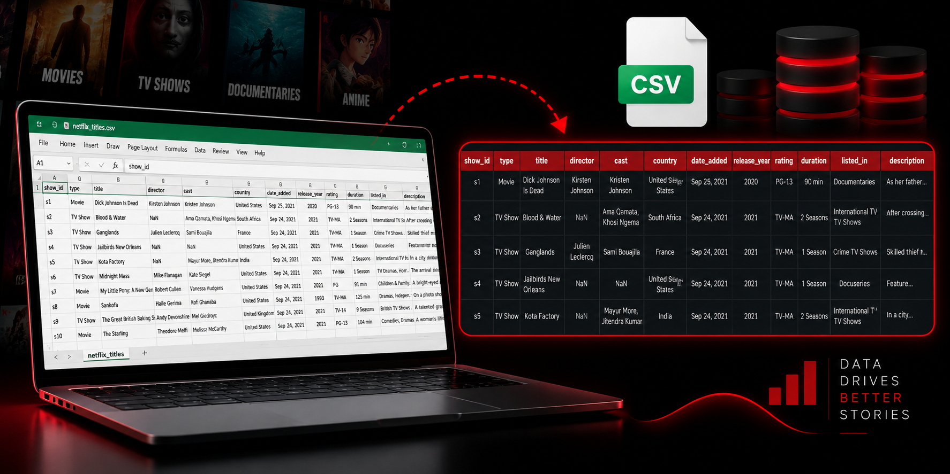
4. DATA SET
The Netflix Titles Dataset contains important columns that describe each title. The following table explains the main fields used in the project.
Column Name | Description | Data Type
show_id | Unique identification number of the content title | Text
type | Identifies whether the title is a Movie or TV Show | Categorical
title | Name of the movie or television show | Text
director | Name of the director or directors | Text
cast | Actors and actresses appearing in the title | Text
country | Country or countries associated with the title | Text
date_added | Date on which the title was added to Netflix | Date/Text
release_year | Original release year of the title | Number
rating | Content rating or age classification | Categorical
duration | Movie duration or number of TV show seasons | Text
listed_in | Genres or categories associated with the title | Text
description | Short summary or description of the content | Text

The dataset provides enough information to perform content-type analysis, genre analysis, rating analysis, country analysis and time-based analysis. These fields were used to create the charts and KPI cards in the dashboard.
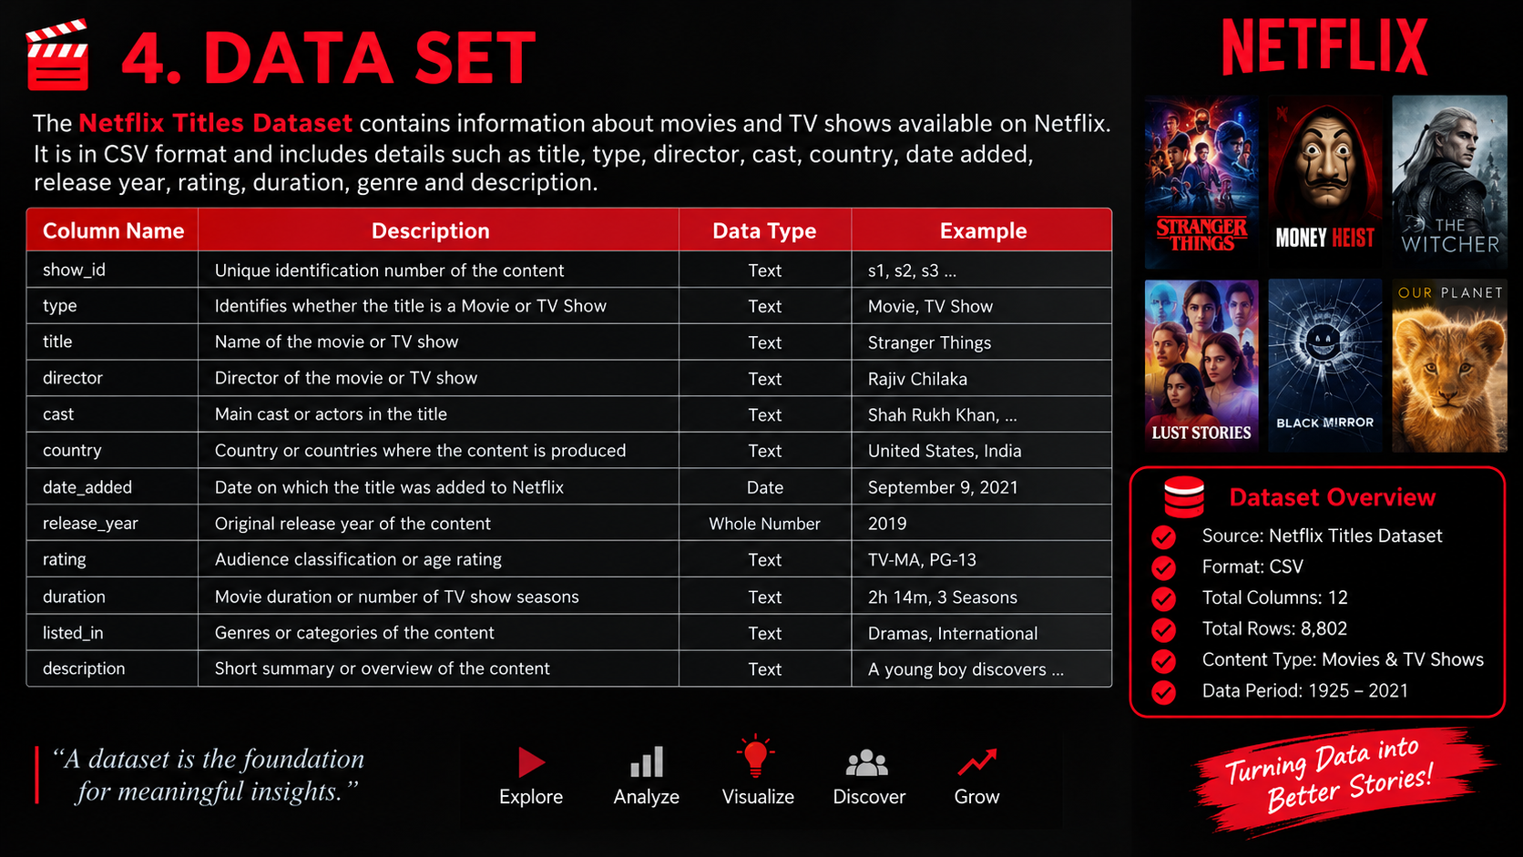

5. TOOLS AND TECHNOLOGIES USED
Microsoft Power BI Desktop
Microsoft Power BI Desktop was the main tool used in this project. It was used to import the Netflix CSV file, create the data model, build visualizations, format the dashboard and present the final results.
Power Query Editor
Power Query Editor was used for data cleaning and transformation. It helped review columns, handle missing values, change data types, remove unwanted spaces and prepare the dataset for analysis.
DAX
DAX, or Data Analysis Expressions, can be used in Power BI to create calculated columns and measures. Measures are useful for calculating totals, counts and other summary values used in KPI cards and charts.
CSV Dataset
The Netflix Titles Dataset was used as the main source of information. CSV format is easy to import and is suitable for storing structured tabular data.
Microsoft Excel
Excel can be used to review the dataset, inspect column values and validate the structure of the source file before importing it into Power BI.
Computer System
A computer system was used to develop the dashboard, prepare the report, save the project and present the final output.
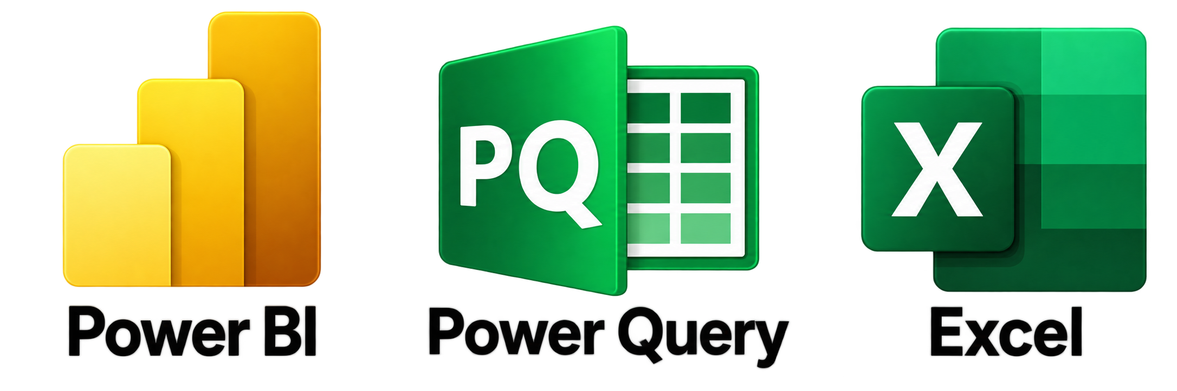
6. DATA CLEANING AND TRANSFORMATION
Data cleaning prepares raw data for accurate analysis. It includes checking missing values, duplicate records, extra spaces and incorrect data types.
The Netflix CSV file was imported into Power BI. Column names and data types were reviewed. Missing values in director, cast, country, rating and date_added were checked.
Duplicate records were reviewed using show_id and title. The release_year and date_added columns were prepared for year and month analysis.
The listed_in and country columns were also reviewed because they may contain multiple values. Unnecessary spaces and inconsistent text values were checked.
After cleaning and transformation, the prepared data was loaded into the Power BI data model and used to create charts and the dashboard.
Before Cleaning – Common Problems
- Missing values in director, cast, country, rating or date_added
- Incorrect or mixed data types
- Duplicate or repeated records
- Multiple genres or countries in one field
- Extra spaces and inconsistent text values
- Date fields not ready for year or month analysis
After Cleaning – Expected Improvements
- Missing values were reviewed and handled
- Data types were corrected
- Date fields were prepared for time-based analysis
- Text values were standardized
- Duplicate records were reviewed
- The dataset became suitable for counting, filtering and visualization
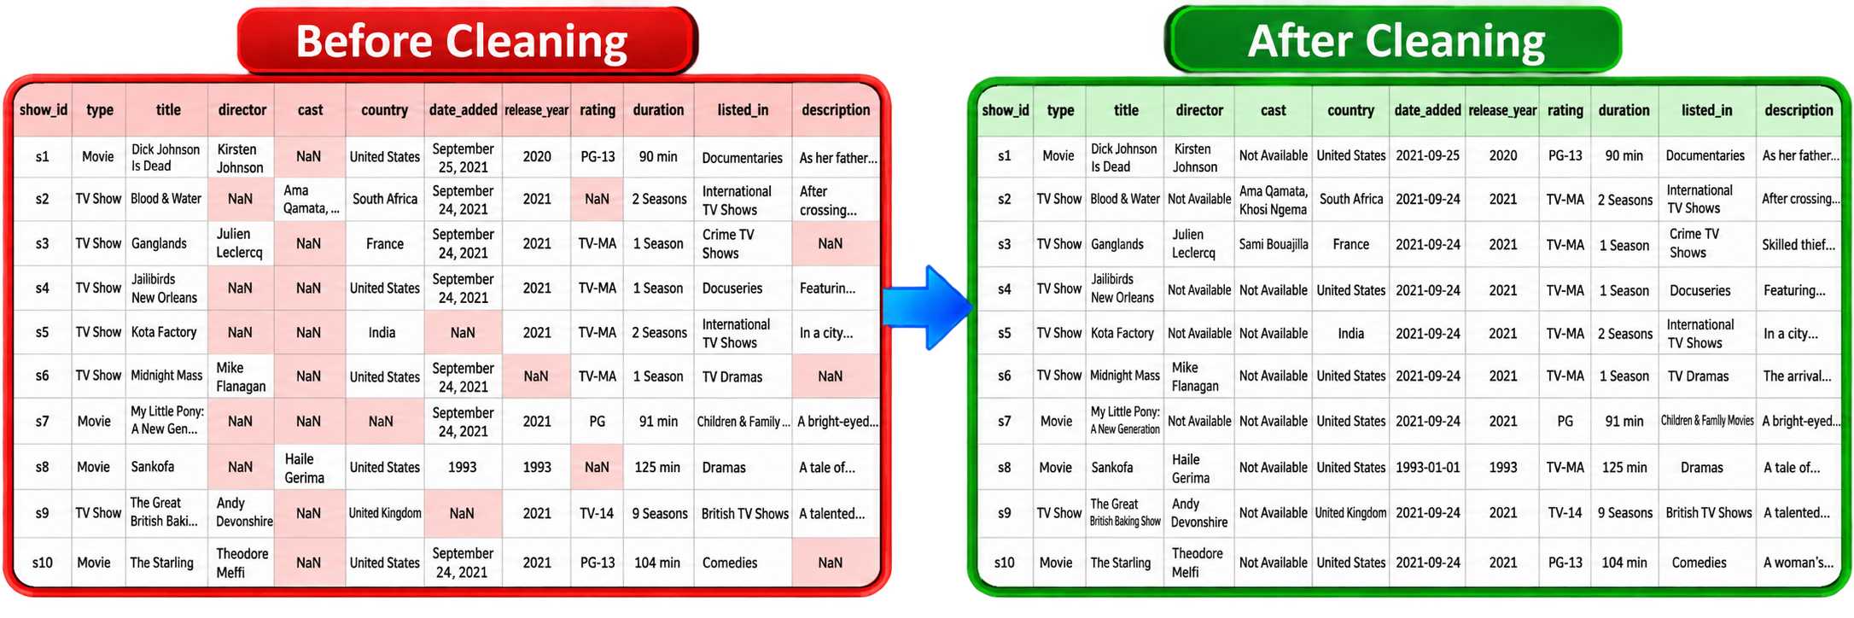
7. DATA ANALYSIS
After data cleaning and transformation, the dataset was analyzed using Power BI. The analysis focused on the content type, genres, ratings, countries, release years and the date on which content was added to Netflix.
The first analysis compared Movies and TV Shows. This helped identify the main content mix in the dataset. The donut chart makes this comparison easy because the size of each section represents the share of each content type.
Genre analysis was performed to identify common content categories. Genres such as Dramas, International Movies, Documentaries and Stand-Up Comedy appear prominently in the displayed dashboard.
Rating analysis was performed to understand audience classification. Ratings such as TV-MA and TV-14 are clearly visible in the rating charts. These values help explain the type of audience targeted by different titles.
Country analysis was performed using a treemap. The treemap compares the contribution of different countries. The United States occupies the largest area in the displayed chart, followed by India and other countries.
Release-year analysis was performed to understand how titles are distributed across years. The chart shows fewer titles in older years and a stronger concentration of titles in more recent years.
Monthly content analysis was performed using the date_added field. The line chart shows that the number of titles added changes from month to month. This helps identify monthly variation in content additions.
All these analyses were combined into a single dashboard so that users can understand the dataset quickly without reading every individual record.
Questions Answered by the Analysis
- How many titles are available?
- Are Movies or TV Shows higher in number?
- Which genres are common?
- Which ratings have more titles?
- Which countries contribute the most content?
- How are titles distributed by release year?
- How does content addition change by month?
- How are age certifications distributed by content type?

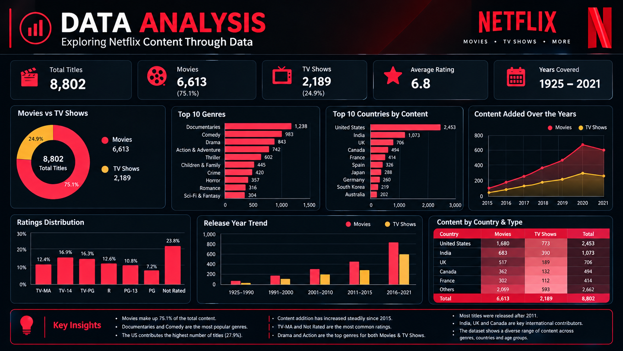
8. VISUALIZATIONS
Visualizations convert raw data into charts and graphs that are easier to understand. In this project, eight main visualizations were created. Each chart focuses on a specific question and provides a different view of the Netflix dataset.
1. Genres by Total Titles
This bar chart compares the number of titles across different genres. The chart shows categories such as Dramas, International Movies, Documentaries and Stand-Up Comedy. The length of each bar represents the number of titles in that genre. Longer bars indicate genres with more titles.
2. TV Shows and Movies
This donut chart compares the two main content types. The red section represents Movies and the light-pink section represents TV Shows. In the displayed dashboard, Movies occupy the larger portion, showing that Movies are more numerous than TV Shows.
3. Ratings by Total Titles
This bar chart shows the number of titles under different ratings. TV-MA and TV-14 are among the most visible ratings. The chart helps explain the distribution of audience classifications in the dataset.
4. Top 10 Countries by Movies and TV Shows
This treemap compares countries according to the number of titles associated with them. Larger boxes represent countries with more titles. The United States has the largest area in the displayed dashboard, followed by India and other countries.
5. Total Movies and TV Shows by Release Year
This area or line chart shows the distribution of Movies and TV Shows according to their release year. The chart shows a low number of titles in older years and a strong increase in recent years.
6. Movies and TV Shows by Rating
This column chart compares Movies and TV Shows under different rating categories. The two colors make it easy to compare the content types. TV-MA and TV-14 show high values in the displayed chart.
7. Content Added to Netflix by Month
This line chart is based on the new dashboard. It shows the number of titles added during different months. The line changes across months, showing that content additions are not equal in every month.
8. Age Certification by Content Type
This bar chart shows age certification for Movies and TV Shows. It helps understand the audience classification of content and shows that Netflix provides titles for different age groups.

9. POWER BI DASHBOARD
The final Power BI dashboard combines KPI cards and eight visualizations on one report page. The dashboard uses a Netflix-inspired black background with red and light-pink highlights. This color combination makes the dashboard visually attractive and keeps the charts easy to identify.
The KPI cards provide a quick summary of the dataset. The dashboard displays Total Titles, Total Rating, Total Genres, Total TV Shows, Start Date, End Date and Locations.
The first row of charts explains genres, the comparison between TV Shows and Movies, ratings and country contribution. The second row explains release-year trends, rating comparison, monthly content additions and age certification.
The dashboard is useful because it brings different types of analysis together in one place. A viewer can understand the major characteristics of the Netflix dataset by looking at the cards and charts.
KPI Cards Displayed in the Dashboard
- Total Titles: 8802
- Total Rating: 18
- Total Genres: 515
- Total TV Shows: 8807
- Start Date: 1925
- End Date: 2021
- Locations: 749

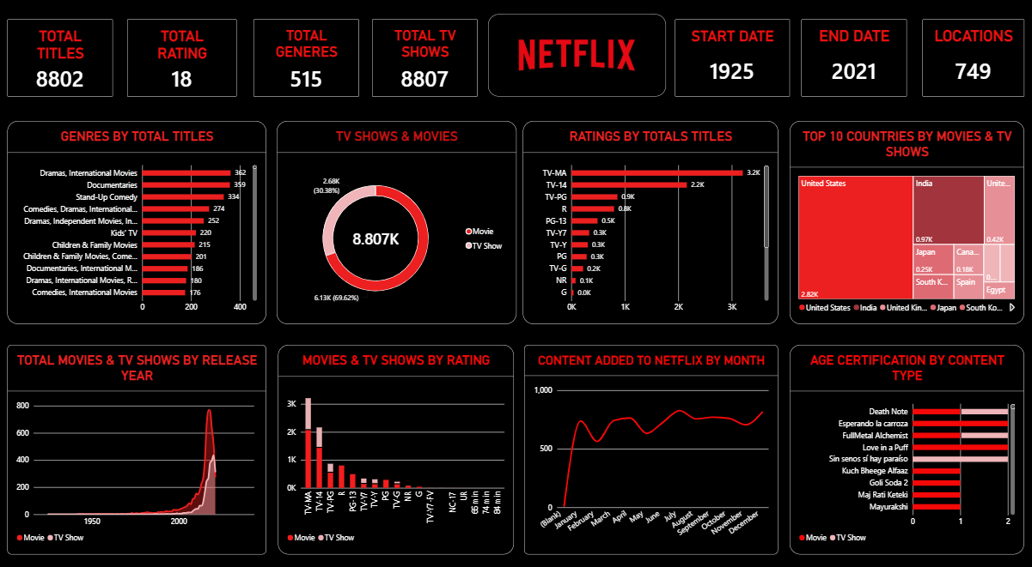
Full Netflix Power BI Dashboard
10. KEY INSIGHTS
The following insights were observed from the charts and KPI cards in the dashboard:
- Movies are more numerous than TV Shows in the displayed content comparison.
- The United States contributes the largest number of titles in the Top 10 Countries treemap.
- India is also an important country contributing Netflix content.
- Dramas, International Movies, Documentaries and Stand-Up Comedy are major genres visible in the genre chart.
- TV-MA and TV-14 are among the most common ratings shown in the ratings chart.
- The release-year chart shows that the number of titles is comparatively low in older years and increases strongly in recent years.
- The monthly content chart shows variation in the number of titles added during different months.
- The age certification chart shows that Netflix content is designed for different audience groups.
- The KPI cards provide a quick summary of the dataset before detailed analysis begins.
- The dashboard presents the data in a clear and organized format, making it easier for users to compare values and identify patterns.

11. CONCLUSION
This project demonstrates how Microsoft Power BI can be used to analyze a real-world entertainment dataset. The Netflix Titles Dataset was imported, reviewed, cleaned, transformed and visualized.
The project provided an understanding of the Netflix content library through different analytical views. Movies and TV Shows were compared, genres and ratings were studied, country contribution was analyzed, and release-year and monthly addition trends were observed.
Data cleaning was an important part of the project because missing values, incorrect data types, duplicate records and inconsistent text can affect the accuracy of analysis. Power Query helped prepare the data for visualization.
The dashboard presents the results in a simple and professional format. KPI cards provide summary information, while charts provide detailed comparisons and trends.
Overall, this project improved my practical knowledge of data preparation, Power Query, DAX concepts, data visualization and dashboard design. It also helped me understand how raw data can be converted into useful business and entertainment insights.

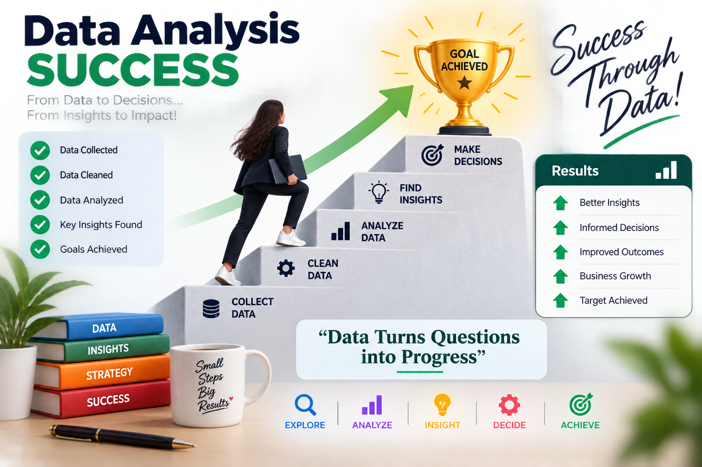
12. PROJECT SUMMARY
The Netflix Content Analysis project was completed using Microsoft Power BI and the Netflix Titles Dataset. The project followed a complete data analytics workflow from importing the data to presenting the final dashboard.
Project Title | Netflix Content Analysis
Tool Used | Microsoft Power BI
Dataset | Netflix Titles Dataset
Main Content Types | Movies and TV Shows
Main Visualizations | Bar chart, donut chart, treemap, area/line chart and column chart
KPI Cards | Total Titles, Total Rating, Total Genres, Total TV Shows, Start Date, End Date and Locations
Analysis Areas | Genres, ratings, countries, release years, monthly additions and age certification
Cleaning Activities | Missing-value review, data-type checking, duplicate review and text/date transformation
Final Output | Netflix-style Power BI dashboard
Learning Outcome | Improved knowledge of data cleaning, analysis, visualization and reporting
The final outcome of the project is an organized and visual report that explains the Netflix dataset and presents the major observations through an interactive Power BI dashboard.

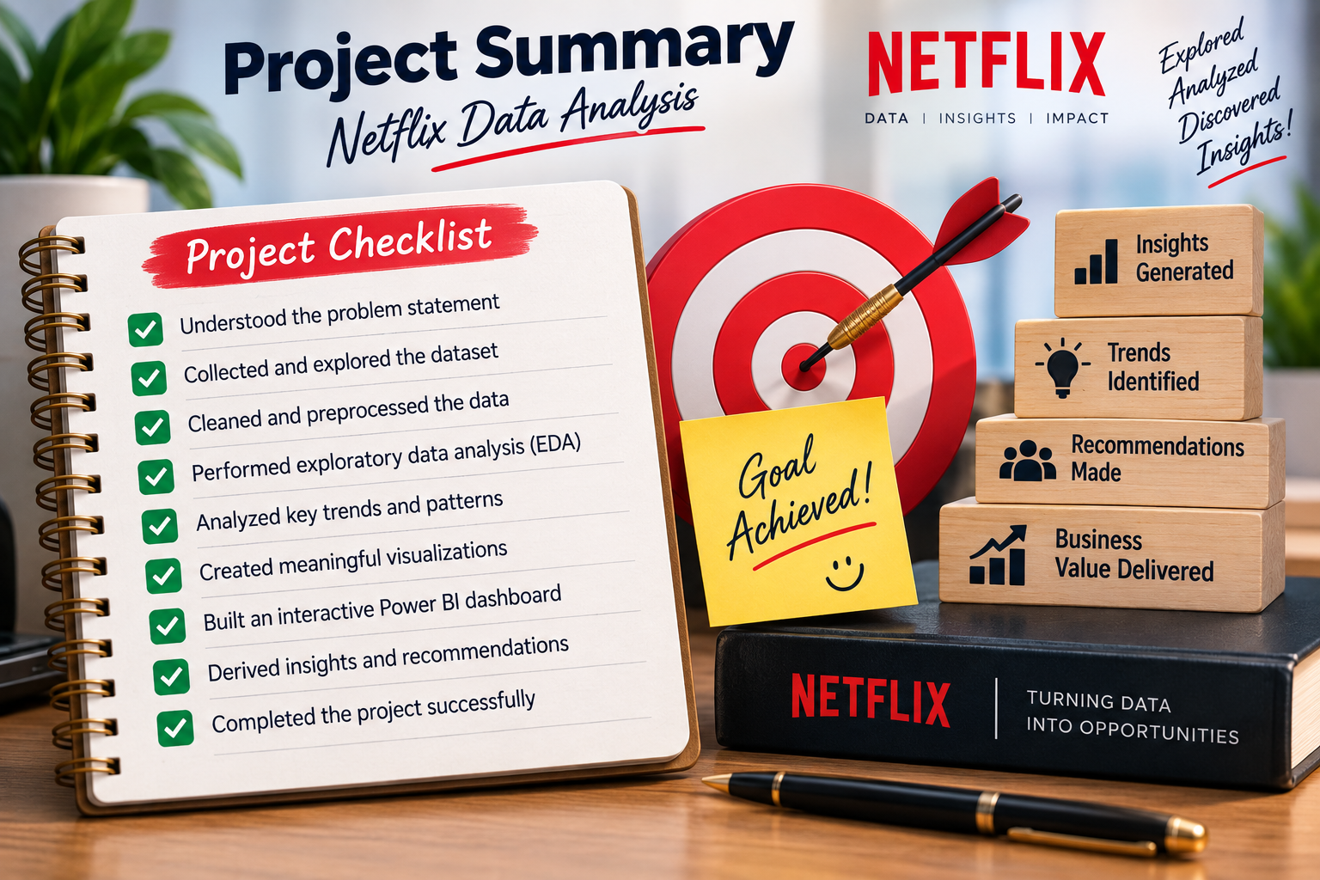

Github Link:

Kaggle Link:
https://www.kaggle.com/datasets/shivamb/netflix-shows

